**BSc (Hons) in Information Technology**

**Software Engineering – Year 3 Semester 2, 2022**

**SE3050 – User Experience engineering**

**Milestone 02**

**Team BIKO - SER_027**

IT20150266 Basnayaka A.I

**Table of Contents**

Table of Contents

**Goal3**

**Research questions** **3**

**Method**

**1. Interviews4**

**2. Video Recordings6**

**3. Questionnaires6**

**Participant Profiles14**

**Prototype 16**

Goal

**Tea Seller**

According to my persona, looking for a better alternative to save time to business in a busy schedule is my main goal. To achieve this goal, I want to plan user research to clearly understand the experience that the user is getting usually. I am going to find out what are the problems faced by the tea sellers in tea leaf handing over process and enhance their lifestyle of them, through this user research for my persona.

Research Questions

**Tea Seller**

How to record tea harvest details in a more accurate and safe way

How to gain awareness of Lorry route details to sell tea harvest on time

How to gain awareness of Tea Harvest prices according to the market.

How to do accurate payment transactions

How to communicate with tea factory managers to solve their problems to get a better solution within a short period.

Method

* Interviewing

|  |
| --- |
| Hi, how are you doing today?  Thank you for lending your valuable time for us today!  We will start with some questions, so please share your honest thoughts as we go along. There are no right or wrong answers.  Do you have any questions for me before we get started?  Before we begin could I just confirm that you are still okay with this session being recorded and shared  with our module in charge? [wait for reply]  Ok. I will start the recording now. [PRESS RECORD]  (හායි, අද ඔබට කොහොමද? ඔබගේ වටිනා කාලය අද අප වෙනුවෙන් කැප කිරීම ගැන ඔබට ස්තුතියි!  අපි ප්‍රශ්න කිහිපයකින් ආරම්භ කරන්නෙමු, කරුණාකර ඔබේ අවංක අදහස් අප සමග බෙදා ගන්න  ආරම්භ කිරීමට පෙර ඔබට මගෙන් ප්‍රශ්න ඇසිමට තිබේ ද? මෙම සැසිය පට්ගත කීරීම සම්බන්ධයන් ඔබට ගැටලුවක් තිබේ ද?  එසේනම් අපි සැසිය ආරම්භ කරමු.)   1. How long have you been planting tea? (ඔබ කොපමණ කාලයක් තේ වගා කර තිබේද?) 2. Could you tell me the area of the land where you grow tea? (ඔබ තේ වගා කරන ඉඩමේ ප්‍රදේශය මට කියන්න පුළුවන්ද?) 3. That means you are categorized under the small-scale tea landowners. (ඒ කියන්නේ ඔබ කුඩා පරිමාණ තේ ඉඩම් හිමියෙක් ද?) 4. Can small scale tea landowners’ hand over their tea harvest to a factory directly in their own? (කුඩා පරිමාණ තේ ඉඩම් හිමියන්ට තම තේ අස්වැන්න කෙලින්ම තමන්ගේම කර්මාන්ත ශාලාවකට භාර දිය හැකිද?)    1. Then how do you hand over the tea to the factory? (එතකොට කොහොමද තේ කර්මාන්ත ශාලාවට භාර දෙන්නේ?)    2. Do you have any timetable to know about the exact date & time for the lorry to come? (ලොරිය පැමිණීමට නියමිත දිනය සහ වේලාව ගැන දැන ගැනීමට ඔබට කාලසටහනක් තිබේද?)    3. Then how do you get to know the date and time for tea collection? (එතකොට තේ එකතු කරන දිනය සහ වෙලාව දැනගන්නේ කොහොමද?)    4. Have you ever faced any problems because of the lorry delay problems (ලොරි ප්‍රමාදයේ ප්‍රශ්න නිසා ඔබ කවදා හෝ ප්‍රශ්නයකට මුහුණ දී තිබේද?) 5. What are the measurements you get when handing over the tea to the lorry? (ලොරියට තේ දෙන විට තේ මිනුම් ලබා ගන්නේ කේසේද?) 6. What are the measurements you get when collecting the tea? (තේ එකතු කිරීමේදී ඔබට ලැබෙන මිනුම් මොනවාද?)    1. What Is the units you used to measure weight? (ඔබ බර මැනීමට භාවිතා කරන ඒකක මොනවාද?)    2. What are equipments you use to get the measurements? (මිනුම් ලබා ගැනීමට ඔබ භාවිතා කරන උපකරණ මොනවාද?)    3. How do you record the details and the measurements? (ඔබ විස්තර සහ මිනුම් වාර්තා කරන්නේ කෙසේද?)    4. Do you calculate total monthly income every month on your own?( සෑම මසකම මුළු මාසික ආදායම ඔබම ගණනය කරන්නේ කේසේද)       1. If yes, how do you calculate? (ඔව් නම්, ඔබ ගණනය කරන්නේ කෙසේද?)          1. Are that process gives you a hundred percent correct result?( එම ක්‍රියාවලිය සියයට සියයක්ම නිවැරදි ප්‍රතිඵලයක් ලබා දෙනවාද?)       2. If not, do you only believe the payment calculation done by the factory?( එසේ නොමැති නම්, ඔබ විශ්වාස කරන්නේ කර්මාන්ත ශාලාව විසින් සිදු කරන ලද ගෙවීම් ගණනය කිරීම පමණක්ද?)          1. Do you trust that calculation all the time?( ඔබ හැම විටම එම ගණනය විශ්වාස කරනවාද?) 7. How do you get to know about the price ranges of the tea leaf market? (තේ දළු වෙළඳපොලේ මිල පරාසයන් ගැන ඔබ දැන ගන්නේ කෙසේද?) 8. Do you have smart mobile device users at your home? ( ඔබගේ නිවසේ ස්මාර්ට් ජංගම උපාංග භාවිතා කරන්නන් සිටීද?)    1. If yes, is that the person who helps you to control your social media accounts? ( ඔව් නම්, ඔබේ සමාජ මාධ්‍ය ගිණුම් පාලනය කිරීමට ඔබට උදවු කරන්නේ ඒ පුද්ගලයාද?) |

* Video recording

Link -https://drive.google.com/drive/folders/1rWspk_ER7TADtETgKVFO8nsQHG0lgQRy?usp=sharing

* Questionnaire

Link to the Google Form - <https://forms.gle/UKx3cvigAEw3s7i89>

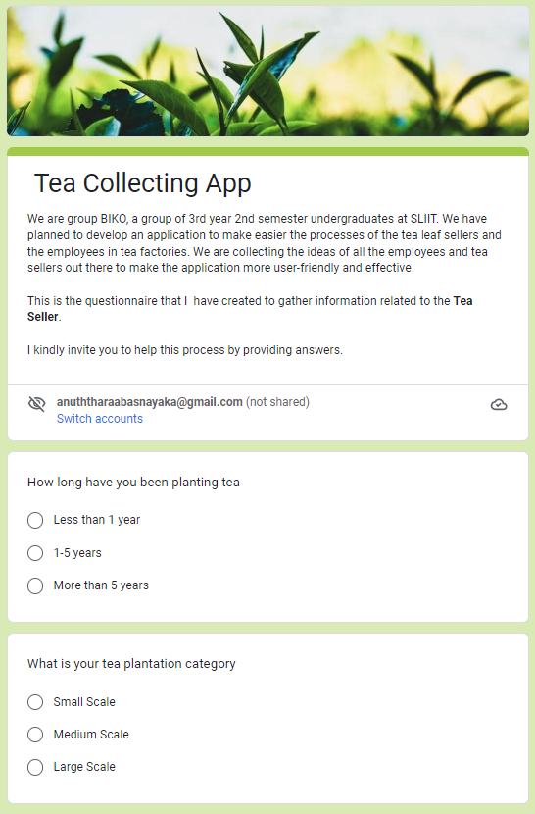

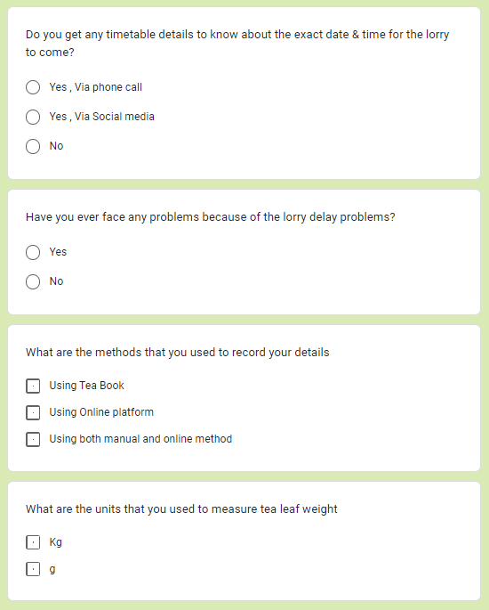

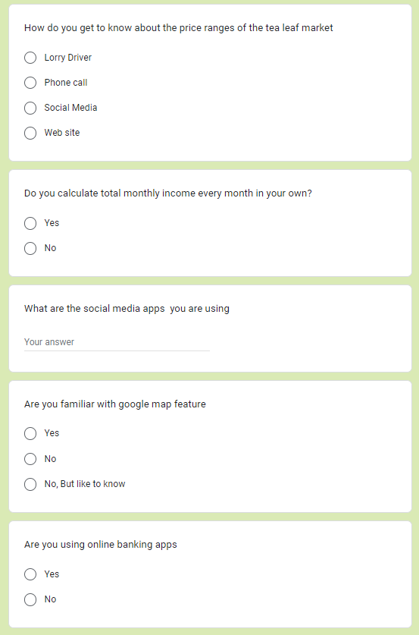

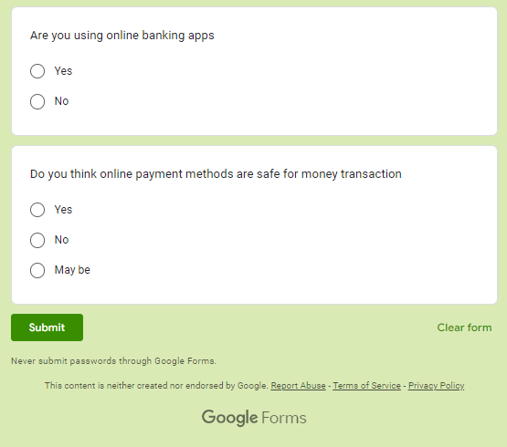

**Responses**

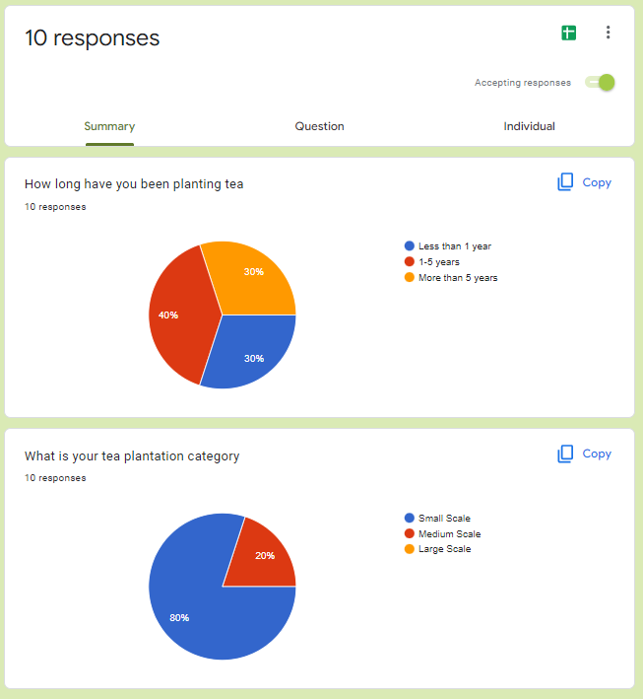

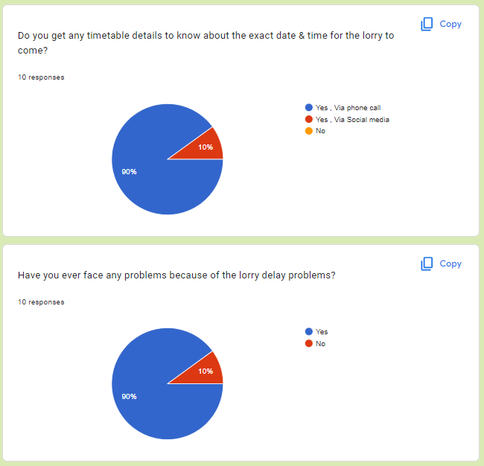

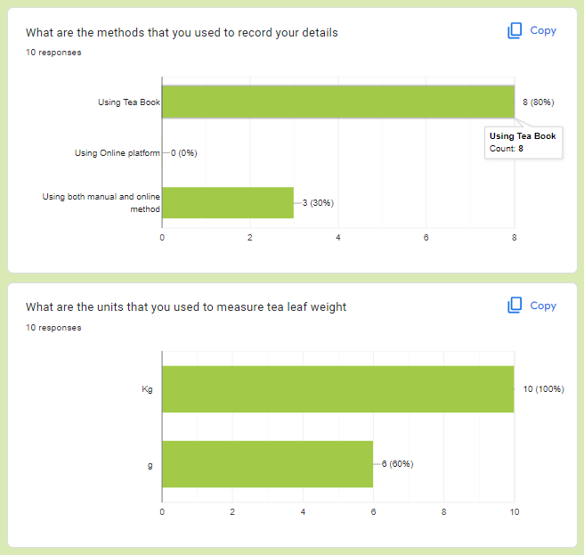

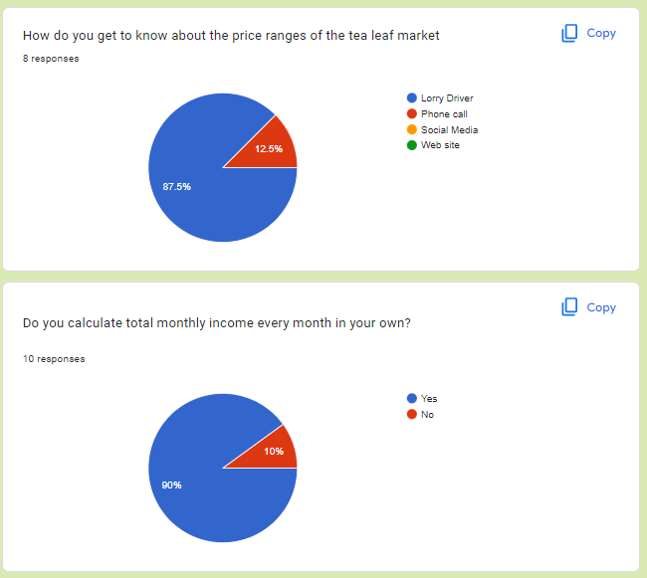

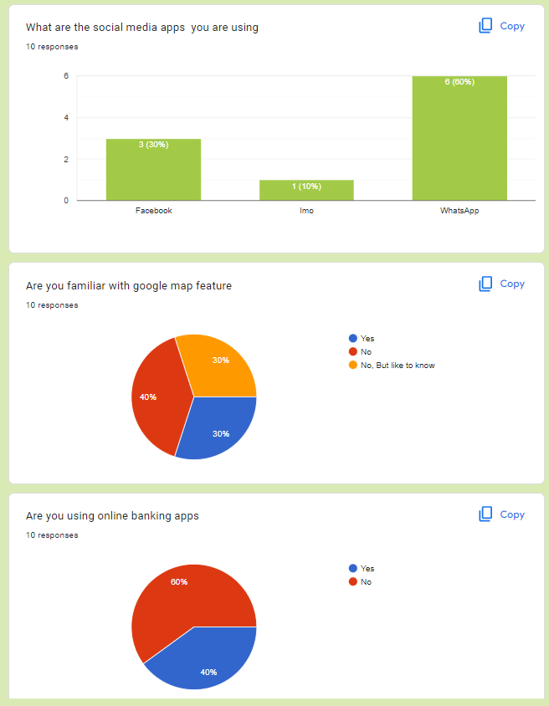

Participants

|  |
| --- |
| Mrs. Chandima Gayani Dhanayaka Yapa (Mrs. Pathirana)    **Age:** 46 years  **Gender:** Female  **Marital Status:** Married with 2 children  **Location:** Athuraliya, Kamburuitiya, Southern Province Sri Lanka  **Profession:** Entrepreneur  **Date:** 2022/Sep/24  **Time:** 11.30 am  Location details: |

Protocol

The user research was planned to be conducted as a user interview session. We found real users match my personas and decided to meet them in their real environments (Physical Mode). I have selected a tea seller and a small tea landowner who lives in a village called, Athuraliya, which is in kamburupitiya, Southern Province. At first, we visit the tea plantation land and talk with tea pluckers, and we planned to conduct the interview on 24th September 2022 at 11.30 a.m. in her home.

And I distributed the google form among the tea sellers to get an idea about the Tea selling process and payment transaction methods.

When conducting the interview, I visited the real environments where the actual process is happening. As my Persona is related to a tea seller, I have visited Mr. Pathirana’s home to meet Mrs. Chandima Gayani Dahanayaka Yapa who is the wife of Mr. Pathirana. where they gather the plucked tea and hand over to the lorry.

Here we conducted the Interview and gathered information with related to the tea seller process.

I planned to check the literacy of smart device usage and social media app usage (google map). I have a goal to check whether this mobile application solution will be helpful to them and to find out ways to make the application more user friendly to the user.

